1. Project code structures in Eclipse IDE

**Source-code files Function**

src/com/WelcomeStartMenu.java ---------- Welcome Menu

/BusinessOperation.java ---------- Business Operation Menu

/DeleteFile.java ---------- Delete a user specified file (case sensitive)

/ListFiles.java ---------- List files in ascending order

/SearchFile.java ---------- Search user specified file (case sensitive)

/AddFile.java ---------- Adding a user specified file (case in-sensitive)

FileStorage/dir-a test sub-directory   
 /dir-brc sub-directory   
 /aa1.txt test file   
 /... ....

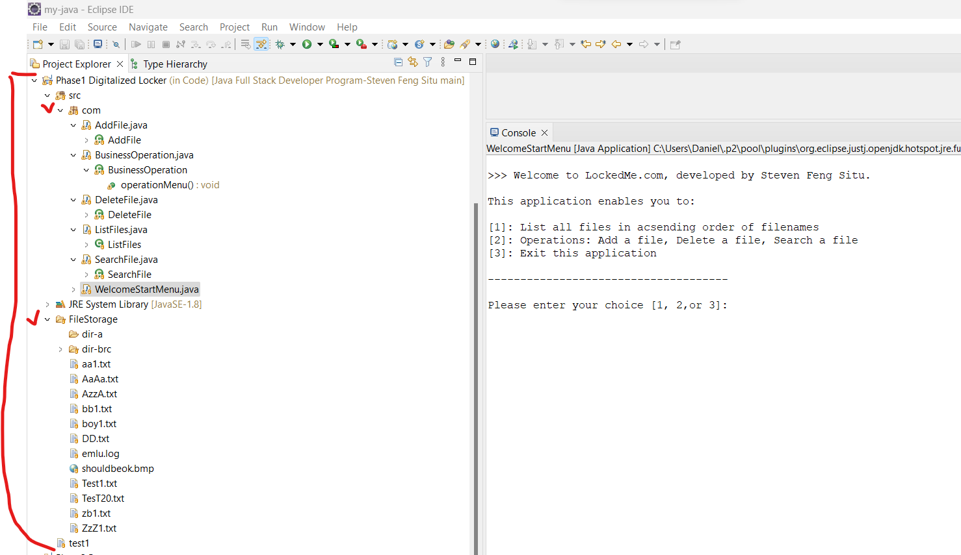

2 Run the program in IDE

Welcome Menu

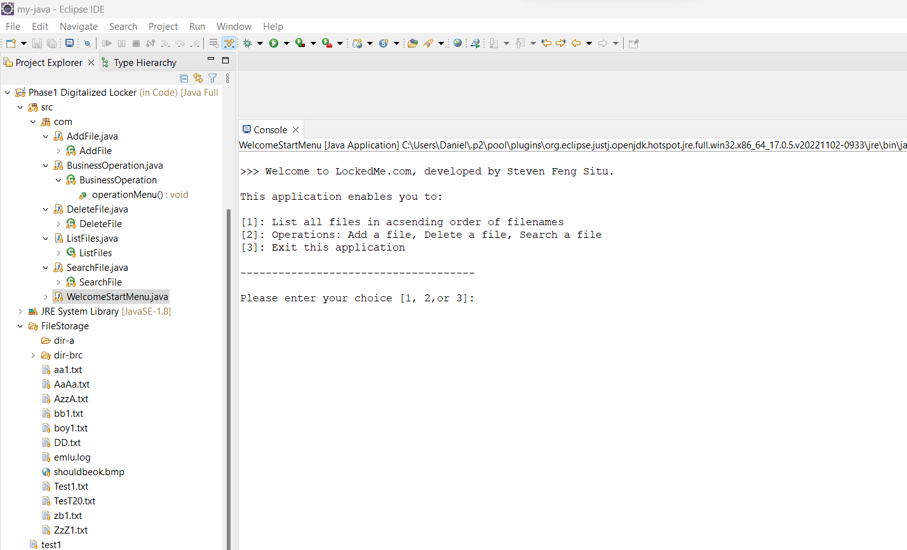

3. User select [1] list all files

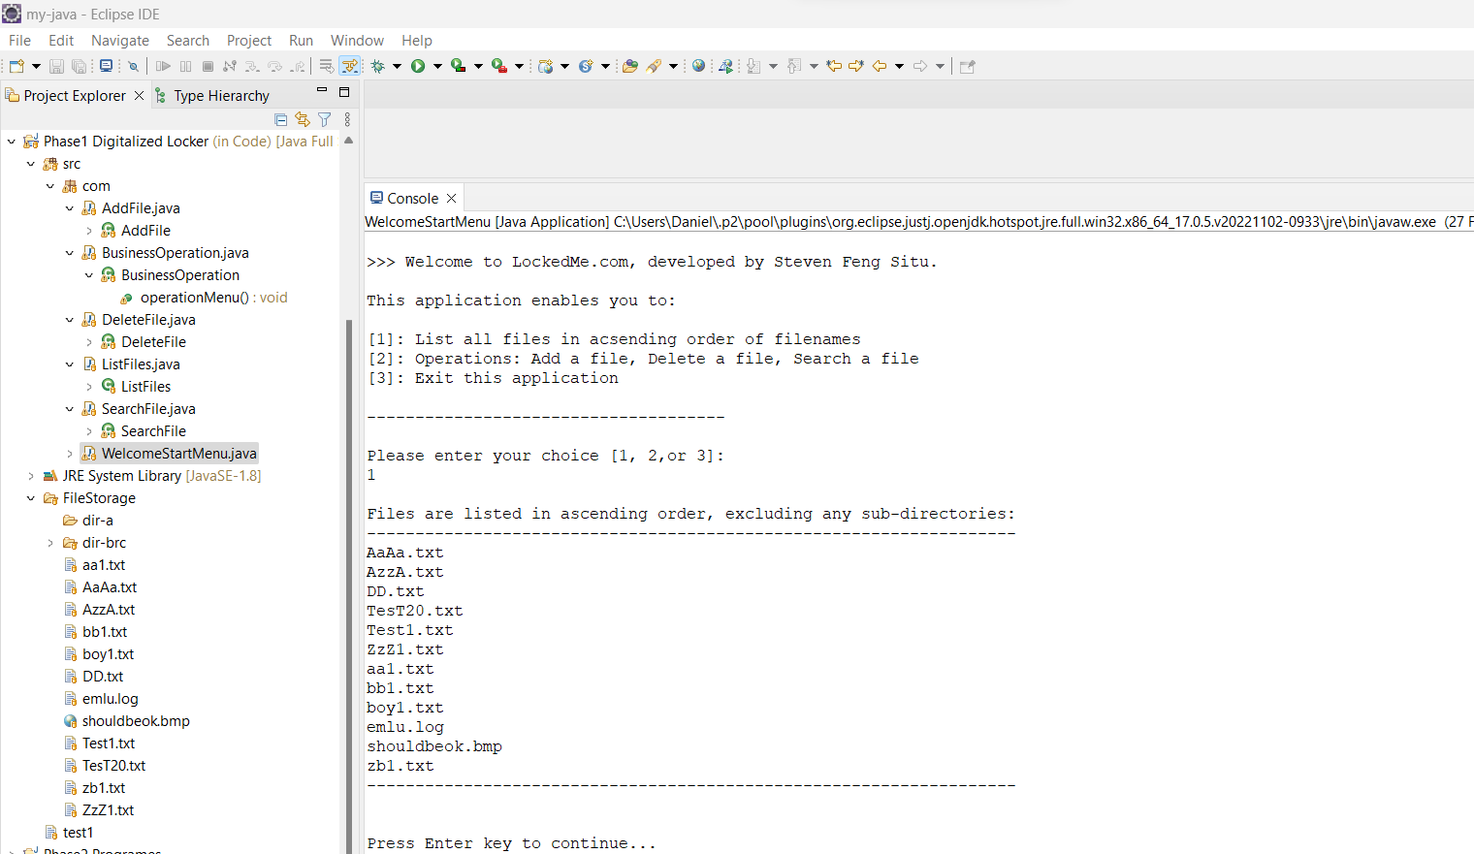

4. Select [2] for Business Operations sub-menu

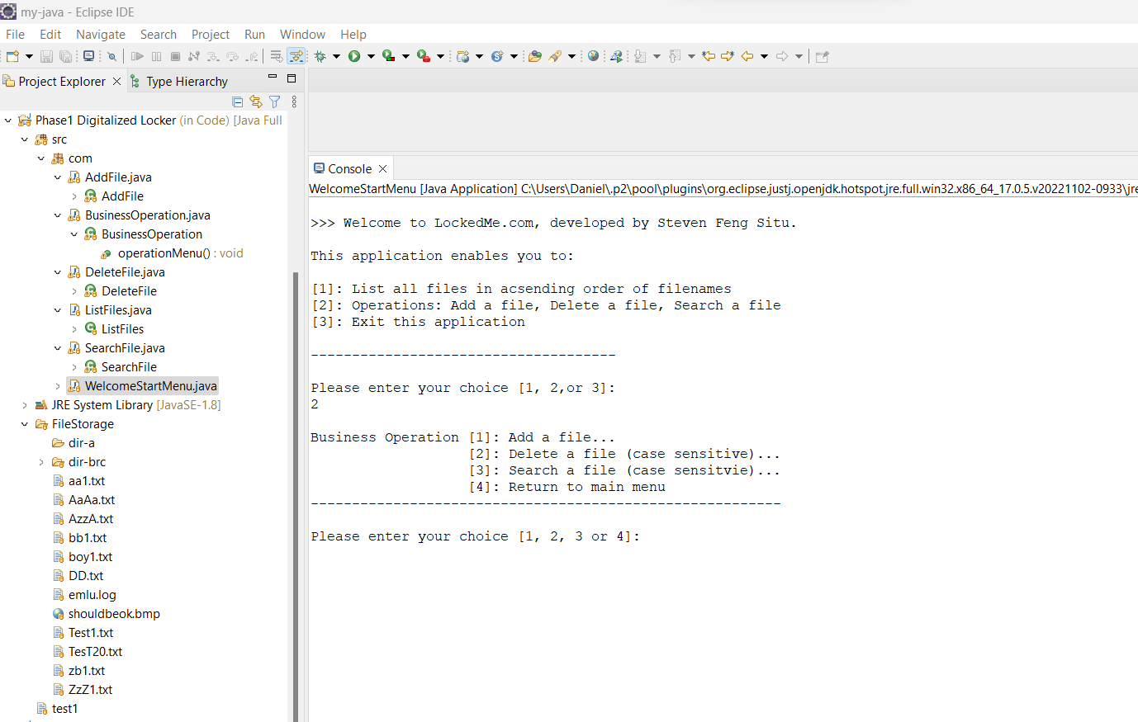

5. Select sub-menu [4] return to Main Welcome Menu

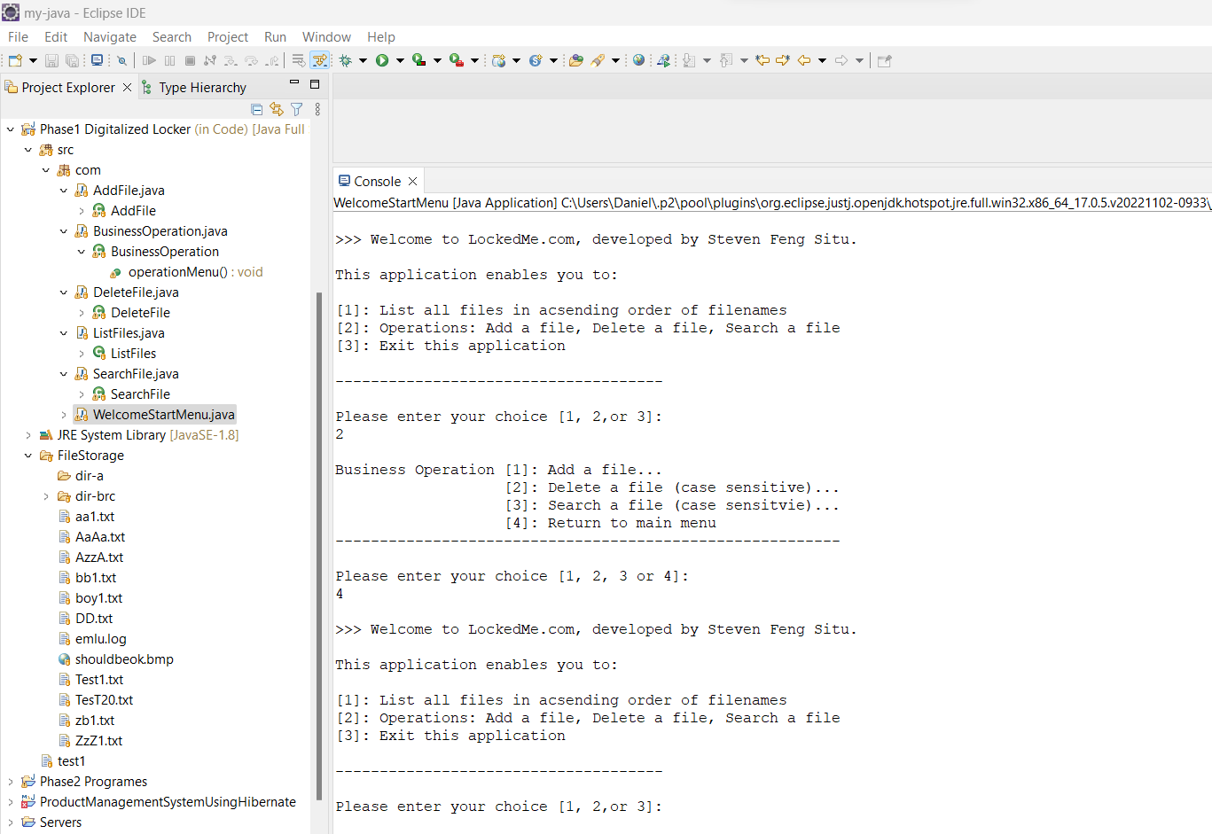

6. Main menu, select [3] to exit program

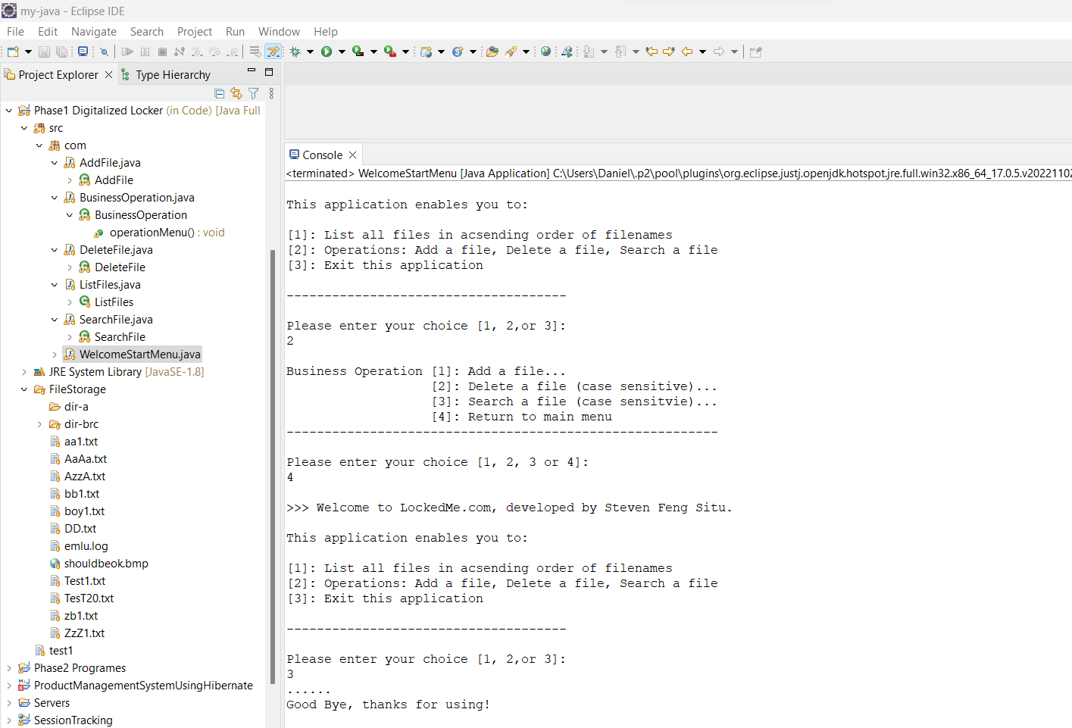

7. Business operation sub-menu, select [1] add a file, file already exists error

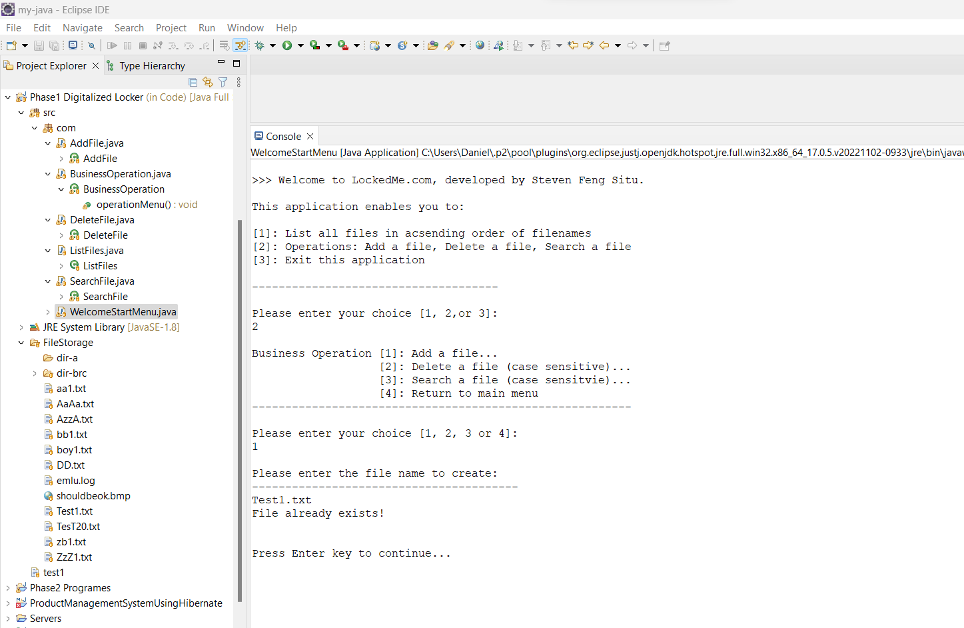

8. Business operation sub-menu , select [1] add a file, successful create a new file

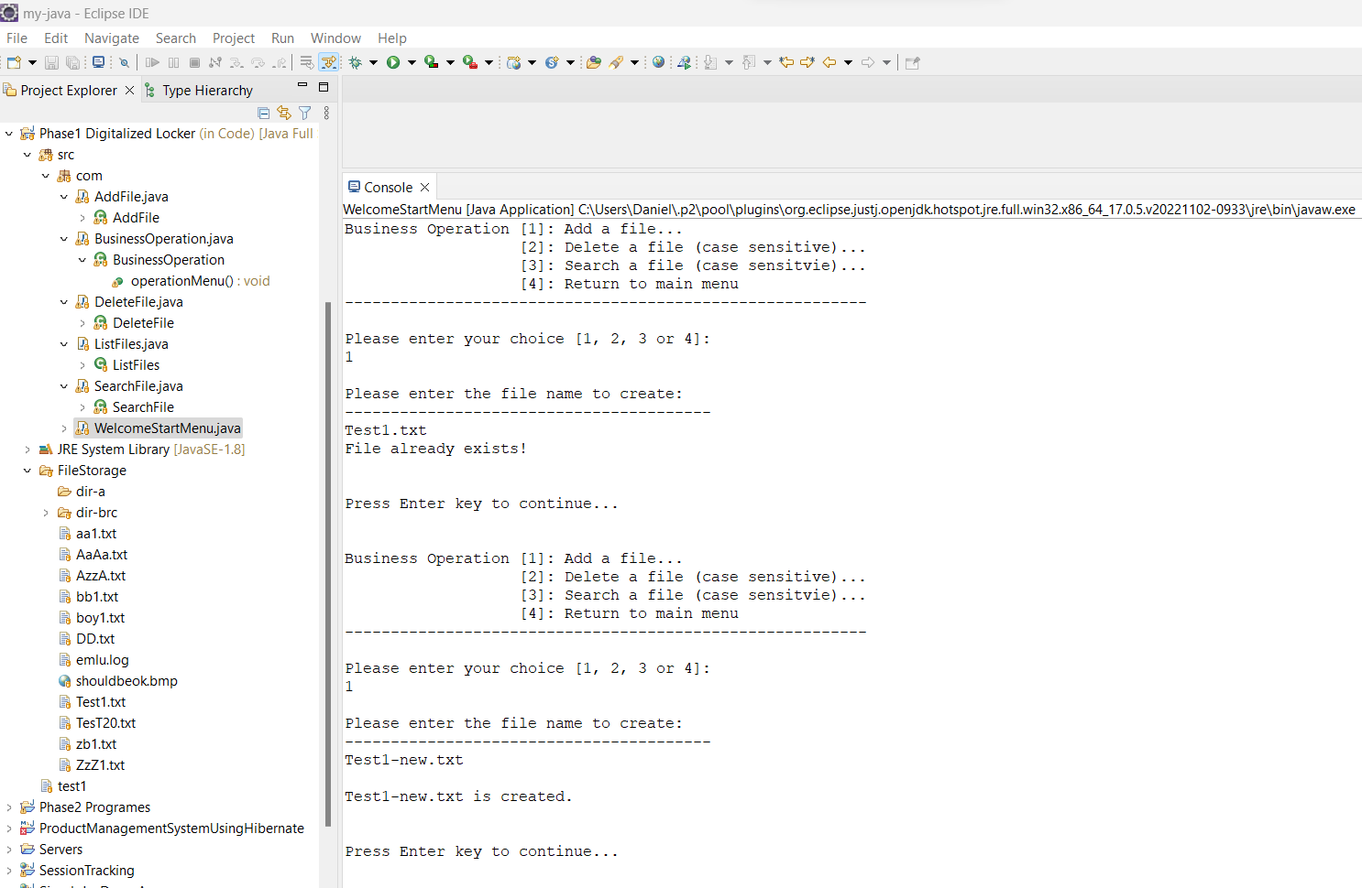

9. Business operation sub-menu , select [2] delete a file, file not found, no deletion

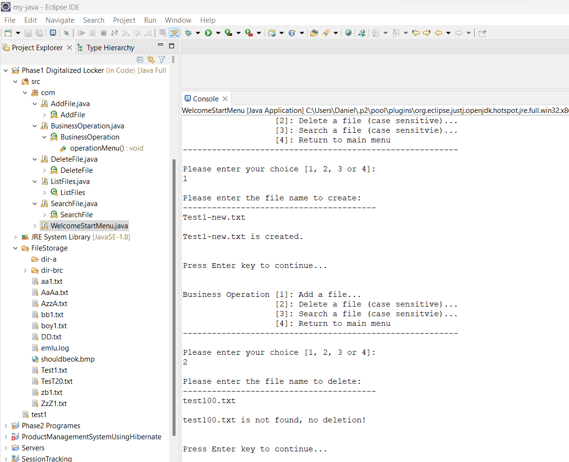

10. Delete a file , case-sensitive , miss-match as case-sensitive, no deletion

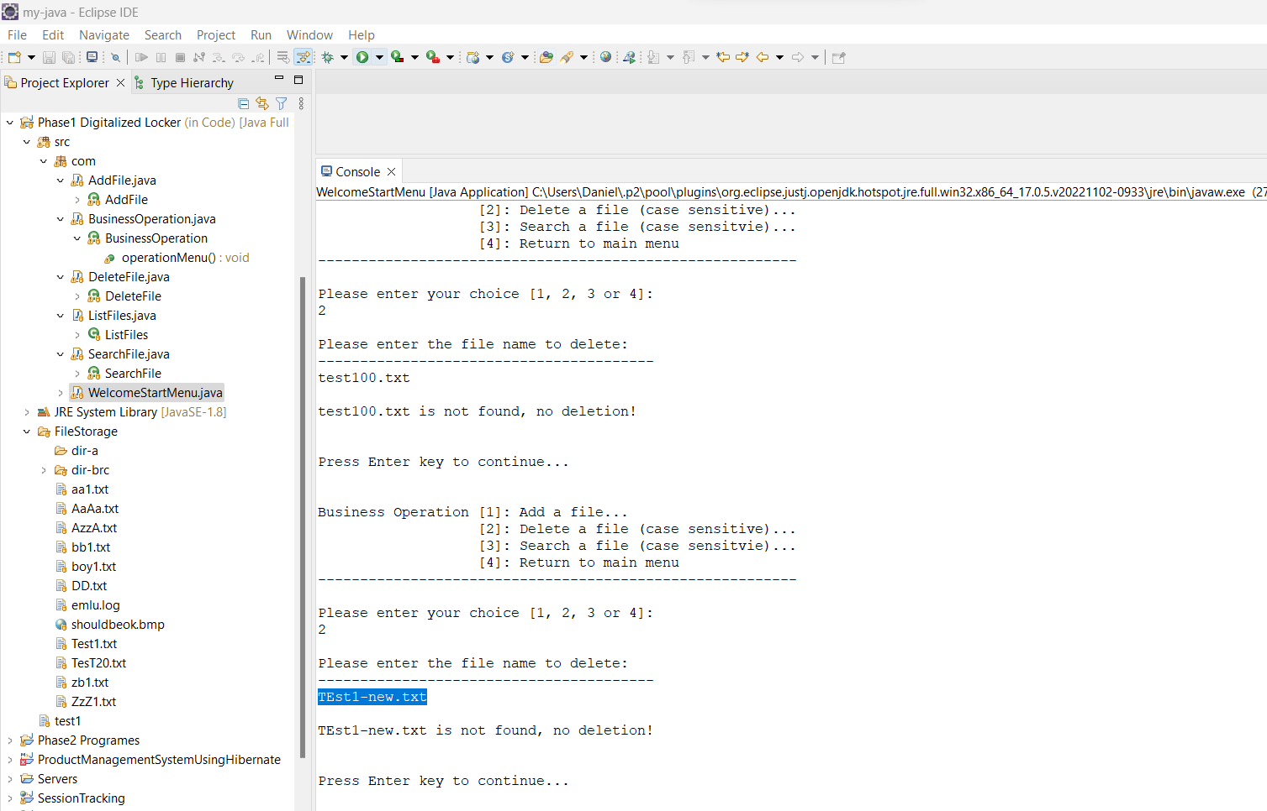

11. Delete a file , match , delete successfully

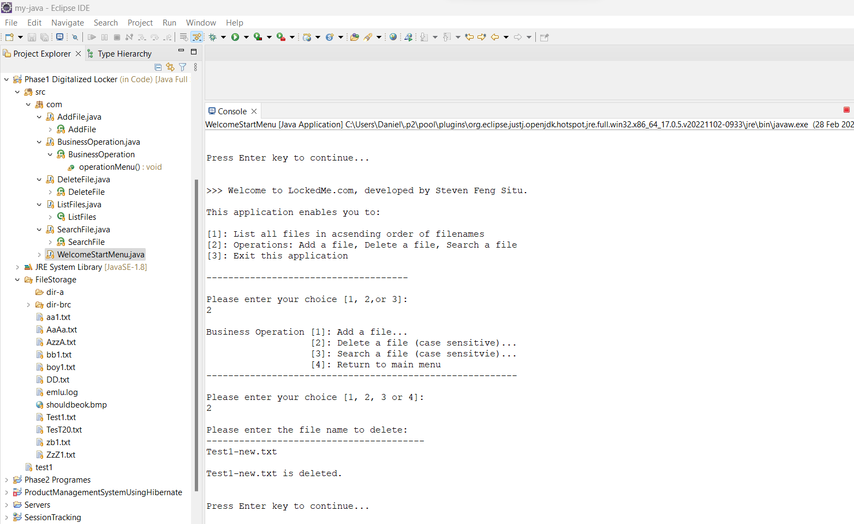

12. Business operation sub-menu [3], Search user specified file, success search

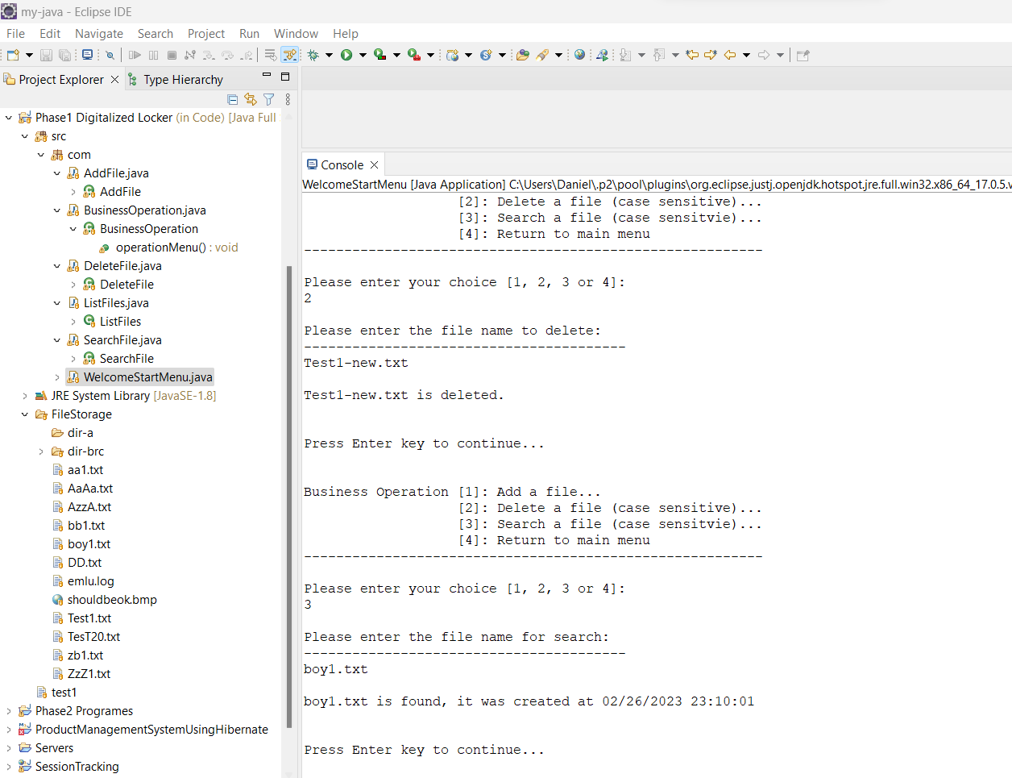

13. Sub-menu [3] , Search case-sensitive , miss-match , file not found

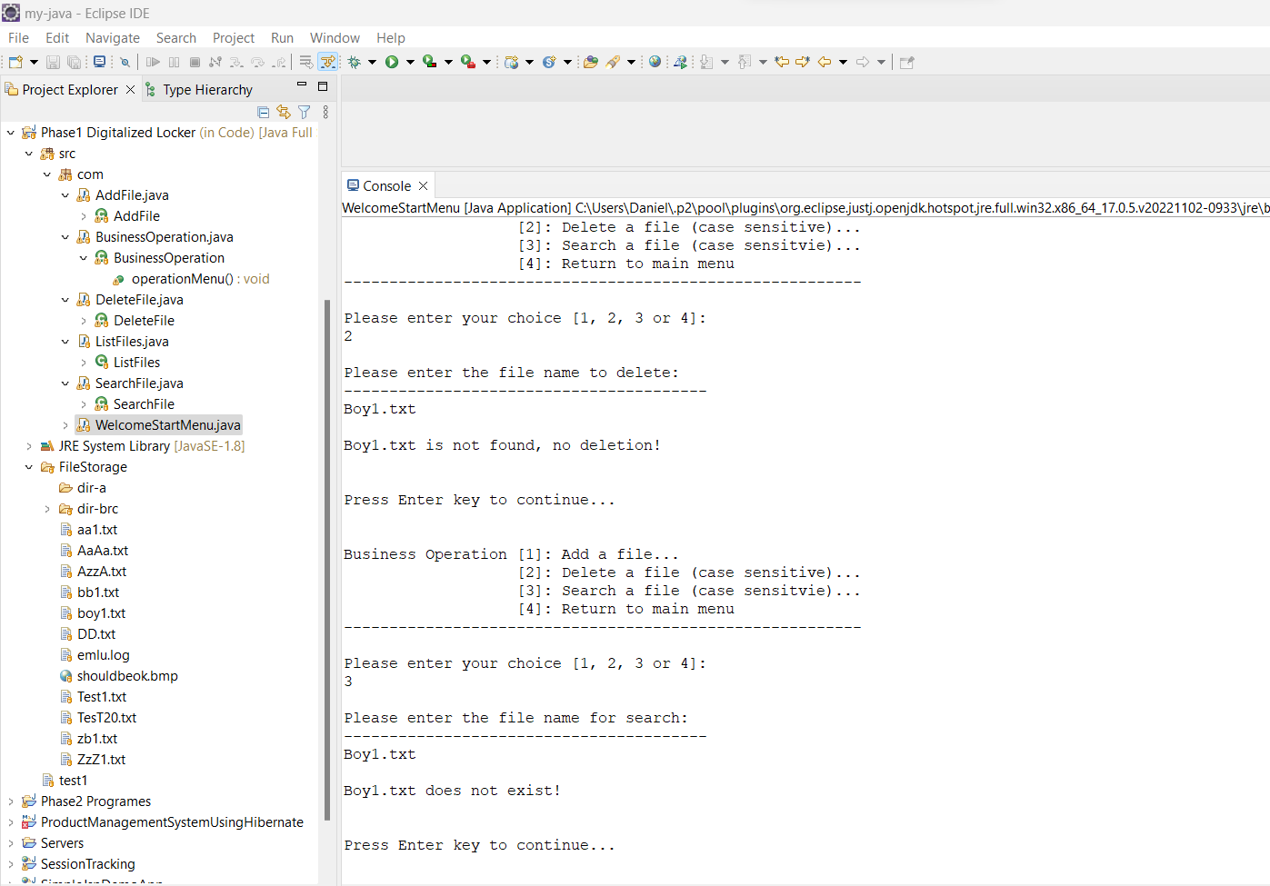

14. Sub-menu [4], return to Main Welcome Menu

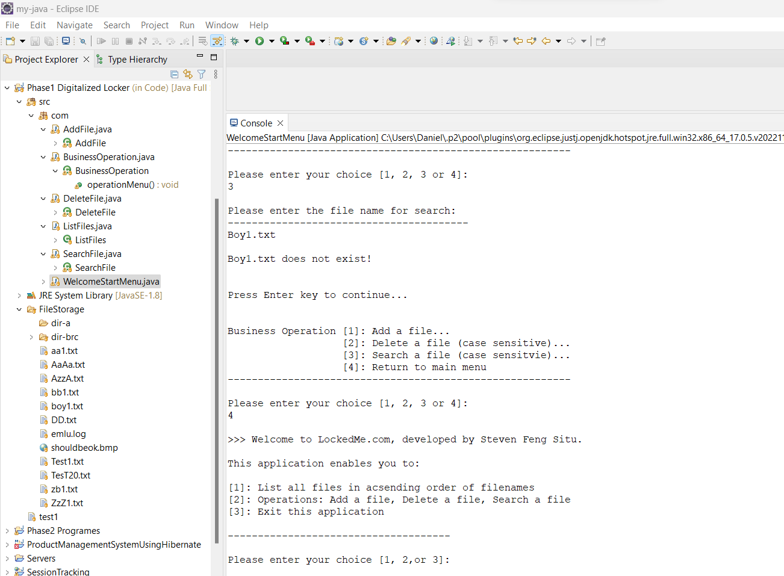

15. All operations exclude sub-directories , only applied to files

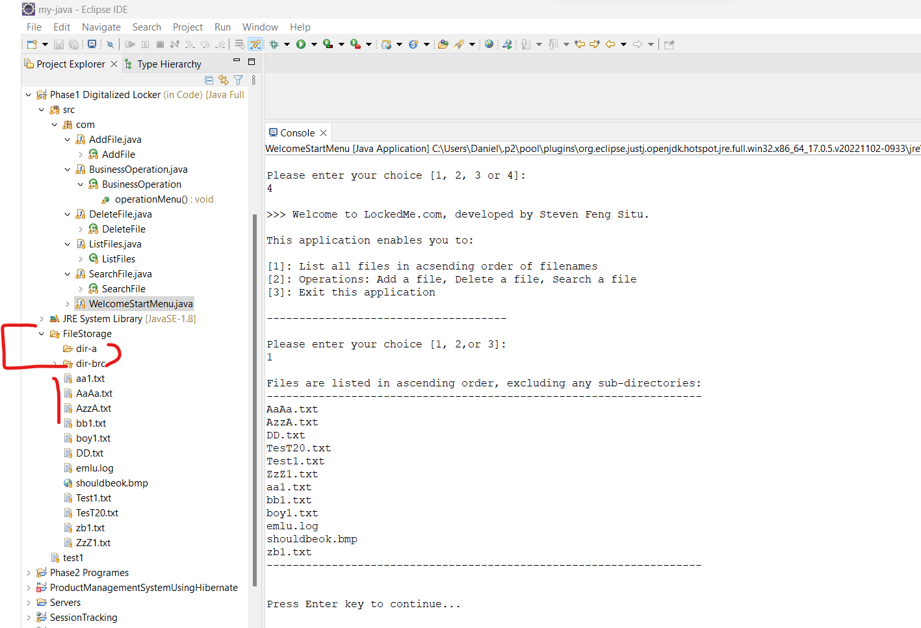

16. Main menu, user input outside of range , prompt to re-select

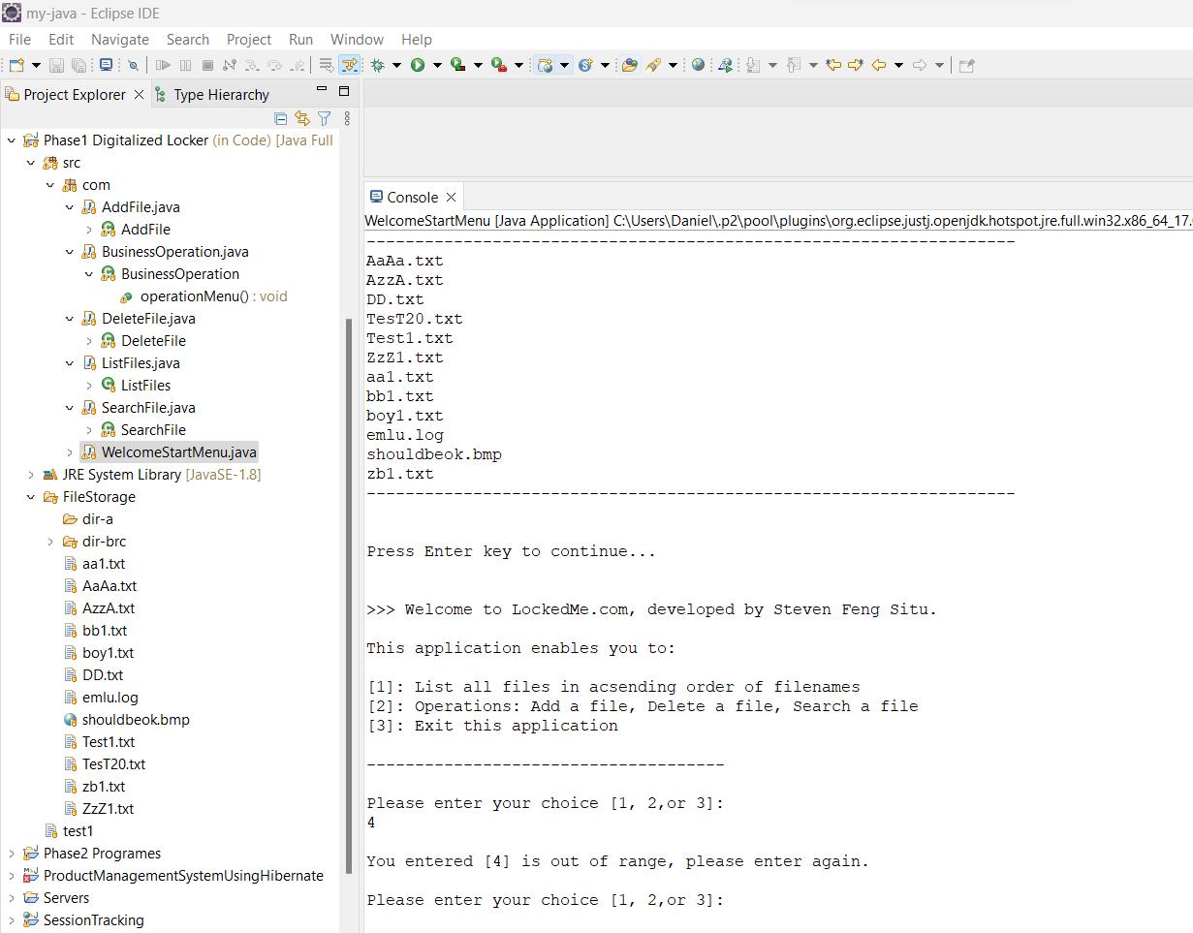

17. Business Operation sub-menu , user input out of range , prompt to re-select

